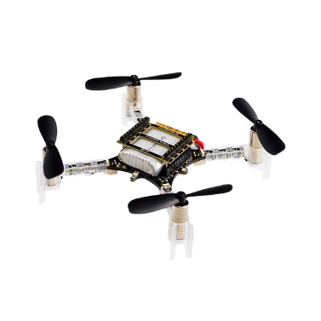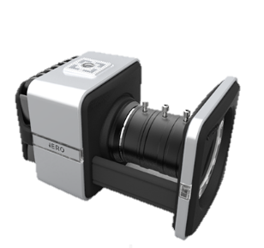

Control messages

*Roll, pitch, yaw rates*

*Position data stream*

(x,y,z,roll,pitch,yaw)

VICON Tracker  
(PC)

Guidance and Control

(PC, python)

*Path*

*Raw vicon data*

Infrared image

*Crazyflie 2.0*

*Vicon camera motion capture system*